How to install jdk in ubuntu
To install JDK (Java Development Kit) on Ubuntu, you can follow these steps to download and set up the latest version available in 2022. As of my last update in January 2022, I'll provide general instructions that should work for the foreseeable future. Here’s a step-by-step guide:

Step 1: Update Package Repository
First, update your package repository to ensure you have the latest version of packages:
sudo apt update

Step 2: Install OpenJDK (Optional)
Ubuntu repositories usually have OpenJDK available. If you prefer OpenJDK (which is free and open-source), you can install it with:
sudo apt install default-jdk
This installs the default OpenJDK version available in Ubuntu repositories.

Step 3: Download JDK from Oracle (Optional)
If you specifically need the JDK from Oracle (for example, for specific features or commercial support), follow these steps to download and install it:
- Download JDK from Oracle:
  - Go to the Oracle JDK download page: Oracle JDK Downloads (or the latest version available in 2022).
  - Download the .tar.gz archive for Linux.
- Extract the Archive:
  - Open a terminal and navigate to the directory where the JDK .tar.gz file is downloaded (usually ~/Downloads).
  - Extract the archive using tar command. Replace jdk-16.0.2_linux-x64_bin.tar.gz with the actual file name you downloaded:
tar -zxvf jdk-16.0.2_linux-x64_bin.tar.gz
- Move JDK Directory:
  - Move the extracted JDK folder to /usr/lib/jvm/ directory (this is a common location for Java installations in Ubuntu):

sudo mkdir -p /usr/lib/jvm
sudo mv jdk-16.0.2 /usr/lib/jvm/

Step 4: Configure Java Environment
Next, configure Ubuntu to use the newly installed JDK. This involves setting up environment variables:
- Set JAVA_HOME:
  - Edit the ~/.profile file to add JAVA_HOME environment variable. Open it with a text editor:
nano ~/.profile
  - Add the following lines at the end of the file:
export JAVA_HOME=/usr/lib/jvm/jdk-16.0.2
export PATH=$PATH:$JAVA_HOME/bin
  - Save and close the file (Ctrl + X, then Y, then Enter).
- Apply Changes:
  - To apply the changes immediately, run:
source ~/.profile

Step 5: Verify Installation
Finally, verify that Java and javac (Java compiler) are installed and configured correctly:

java -version
javac -version
You should see the version information for both commands, indicating that Java JDK is installed and configured properly.

Optional: Set Default Java Version (if multiple versions are installed)
If you have multiple Java versions installed (e.g., OpenJDK and Oracle JDK), you can set the default using update-alternatives:
sudo update-alternatives --config java
Follow the prompts to select the default Java version.
That’s it! You’ve now installed JDK on your Ubuntu system and configured it correctly. Adjust the version numbers and paths as per the specific JDK version you download.
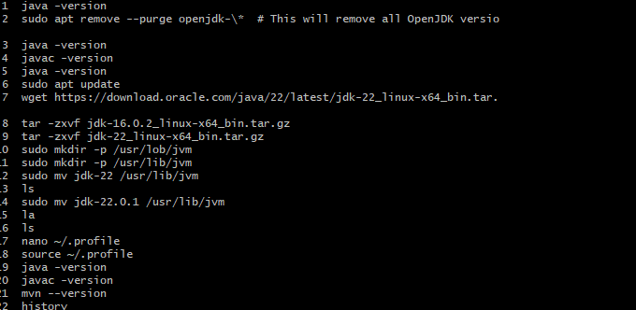

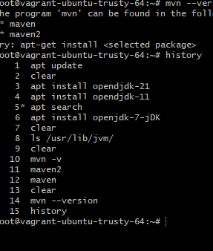\
Top 10 DevOps tools
# | DevOps Tools | DevOps Stage
1. | Git | Code, Build
2. | Gradle | Build
3. | Selenium | Test
4. | Jenkins | Build, Test, Deploy
5. | Puppet | Deploy, Operate
6. | Chef | Deploy, Operate
7. | Docker | Build, Deploy, Operate
8. | Kubernetes | Build, Deploy, Operate
9. | Ansible | Deploy, Operate
10. | eG Enterprise | Monitor

Maven
Maven is a build automation tool used for java project,
Maven build a project using its projects object model pom and set of plugins,
The tool is help to building & doc the projects & management,
Build tool;
1,Generate source code
2,generate documentation from source code compily the source code
Packages the compiled code into jar files installed the packged code in repository
Pom;
Building block in maven
Xml file ----contains information of project & configuratime detailsm by used by maven to build project,
Include plugin used by maven
Build and manged any java based projects
It helps downloading dependences which is libaire or javafiles used in project
Visit; manrepositiry.com [Control repository of maven]
Does ; buildings of project easy

Maven commands ;
On to creating your first project! In order to create the simplest of Maven projects, execute the following from the command line:
mvn -B archetype:generate -DgroupId=com.mycompany.app -DartifactId=my-app -DarchetypeArtifactId=maven-archetype-quickstart -DarchetypeVersion=1.4
compile command is --- mvn compile
output like this
[INFO] Scanning for projects...
[INFO]
[INFO] ----------------------< com.mycompany.app:my-app >----------------------
[INFO] Building my-app 1.0-SNAPSHOT
[INFO] --------------------------------[ jar ]---------------------------------
[INFO]
[INFO] --- maven-resources-plugin:3.0.2:resources (default-resources) @ my-app ---
[INFO] Using 'UTF-8' encoding to copy filtered resources.
[INFO] skip non existing resourceDirectory <dir>/my-app/src/main/resources
[INFO]
[INFO] --- maven-compiler-plugin:3.8.0:compile (default-compile) @ my-app ---
[INFO] Changes detected - recompiling the module!
[INFO] Compiling 1 source file to <dir>/my-app/target/classes
[INFO] ------------------------------------------------------------------------
[INFO] BUILD SUCCESS
[INFO] ------------------------------------------------------------------------
[INFO] Total time: 0.899 s
[INFO] Finished at: 2020-07-12T11:31:54+01:00
[INFO] ------------------------------------------------------------------------
Test command is ----mvn test
Output like this
[INFO] Scanning for projects...
[INFO]
[INFO] ----------------------< com.mycompany.app:my-app >----------------------
[INFO] Building my-app 1.0-SNAPSHOT
[INFO] --------------------------------[ jar ]---------------------------------
[INFO]
[INFO] --- maven-resources-plugin:3.0.2:resources (default-resources) @ my-app ---
[INFO] Using 'UTF-8' encoding to copy filtered resources.
[INFO] skip non existing resourceDirectory <dir>/my-app/src/main/resources
[INFO]
[INFO] --- maven-compiler-plugin:3.8.0:compile (default-compile) @ my-app ---
[INFO] Nothing to compile - all classes are up to date
[INFO]
[INFO] --- maven-resources-plugin:3.0.2:testResources (default-testResources) @ my-app ---
[INFO] Using 'UTF-8' encoding to copy filtered resources.
[INFO] skip non existing resourceDirectory <dir>/my-app/src/test/resources
[INFO]
[INFO] --- maven-compiler-plugin:3.8.0:testCompile (default-testCompile) @ my-app ---
[INFO] Changes detected - recompiling the module!
[INFO] Compiling 1 source file to <dir>/my-app/target/test-classes
[INFO]
[INFO] --- maven-surefire-plugin:2.22.1:test (default-test) @ my-app ---
[INFO]
[INFO] -------------------------------------------------------
[INFO] T E S T S
[INFO] -------------------------------------------------------
[INFO] Running com.mycompany.app.AppTest
[INFO] Tests run: 1, Failures: 0, Errors: 0, Skipped: 0, Time elapsed: 0.025 s - in com.mycompany.app.AppTest
[INFO]
[INFO] Results:
[INFO]
[INFO] Tests run: 1, Failures: 0, Errors: 0, Skipped: 0
[INFO]
[INFO] ------------------------------------------------------------------------
[INFO] BUILD SUCCESS
[INFO] ------------------------------------------------------------------------
[INFO] Total time: 1.881 s
[INFO] Finished at: 2020-07-12T12:00:33+01:00
[INFO] ------------------------------------------------------------------------
If you simply want to compile your test sources (but not execute the tests), you can execute the following:
Test-compile command is
Mvn test-compile

- project This is the top-level element in all Maven pom.xml files.
- modelVersion This element indicates what version of the object model this POM is using. The version of the model itself changes very infrequently but it is mandatory in order to ensure stability of use if and when the Maven developers deem it necessary to change the model.
- groupId This element indicates the unique identifier of the organization or group that created the project. The groupId is one of the key identifiers of a project and is typically based on the fully qualified domain name of your organization. For example org.apache.maven.plugins is the designated groupId for all Maven plugins.
- artifactId This element indicates the unique base name of the primary artifact being generated by this project. The primary artifact for a project is typically a JAR file. Secondary artifacts like source bundles also use the artifactId as part of their final name. A typical artifact produced by Maven would have the form <artifactId>-<version>.<extension> (for example, myapp-1.0.jar).
- version This element indicates the version of the artifact generated by the project. Maven goes a long way to help you with version management and you will often see the SNAPSHOT designator in a version, which indicates that a project is in a state of development. We will discuss the use of snapshots and how they work further on in this guide.
- name This element indicates the display name used for the project. This is often used in Maven's generated documentation.
- url This element indicates where the project's site can be found. This is often used in Maven's generated documentation.
- properties This element contains value placeholders accessible anywhere within a POM.
- dependencies This element's children list dependencies. The cornerstone of the POM.
- build This element handles things like declaring your project's directory structure and managing plugins.

